SAMPLE
UDC 621.396.6.019:536.5.001.24

NUMERICAL SIMULATION OF ONE OF THE MECHANISMS UNDERLYING THE INFLUENCE OF HEAT AND MASS TRANSFER INTENSITY IN RADIOELECTRONIC EQUIPMENT ON THE RELIABILITY OF A NUMBER OF ITS ELEMENTS

G. V. Kuznetsov,¹ G. Ya. Mamontov,² A. V. Titov²

¹Tomsk State Polytechnic University, Tomsk, Russia
²Tomsk State Architectural-Civic Engineering University, Tomsk, Russia

Summary. (up to 150 words).
Keywords: (max 10).

The reliability of radioelectronic equipment (REE) is determined, in conformity with the present day notions [1], first of all by the working temperature T.
In modeling the intensity of failures (λ) of some of the units, blocks or elements of REE use is usually made of the Arrhenius dependence of λ on temperature [2]:

λ(T) = C exp . (1)

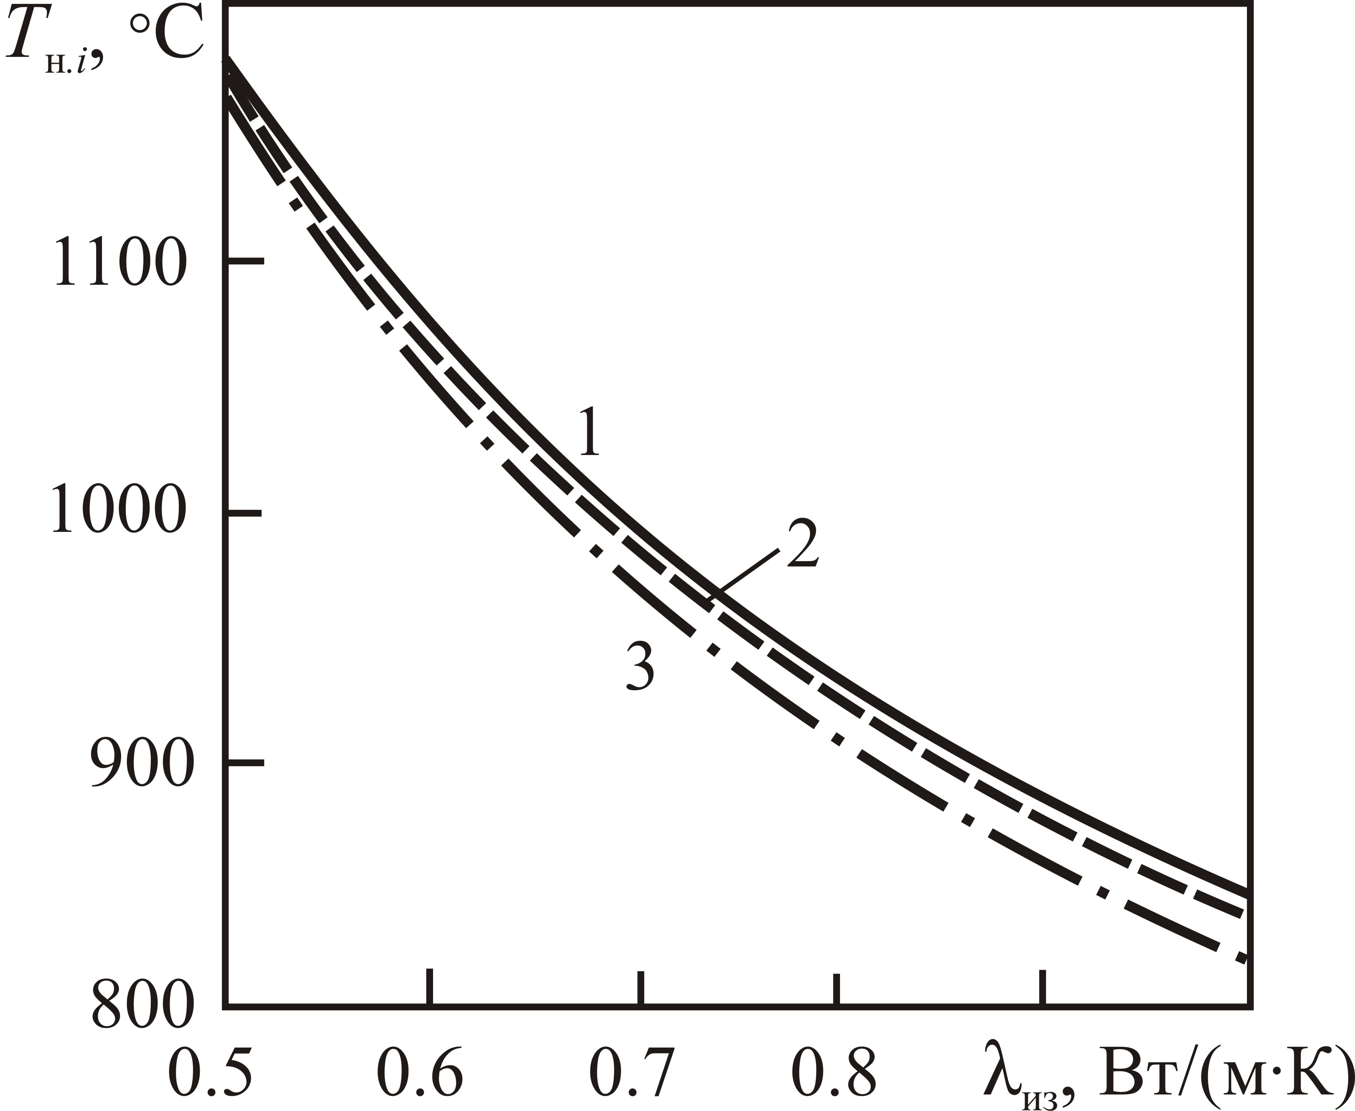
Fig. 1. Dependence of the temperature of heaters T_{h.i} on the heat transfer coefficient λ (P_{h} = 235 W, P_{w} = 500 W): 1) bottom heater; 2) lower side heater; 3) upper heater

Table 1
Normal rates of combustion of fuel mixtures
Chemical composition of a mixture | P, MPa | T, K | u_{n}, m/s
 | 0.108 | 301 | 0.35
0.8C₃H₈ + 0.51H₂ + 5.26O₂ + 19.76N₂ | 0.204 | 296 | 0.32
 | 0.505 | 295 | 0.25
 | 0.102 | 297 | 0.65
0.8(CO + 1.33H₂ + 1.88N₂) + 1.17O₂ + 4.39N₂ | 0.202 | 295 | 0.82
 | 0.601 | 311 | 0.62

Notations

D – diffusion coefficient, m²/s; f – porosity; k permeability, m²; P – pressure, Pa; λ - thermal conductivity, W/(m K); τ - time, s.
References

1. Schlichting H. Boundary Layer Theory. New York: McGraw-Hill Book Company Inc., 1955.
2. Fomin N.A. Speckle Photography for Fluid Mechanical Measurements. Berlin: Springer, 1998.
3. Nikitenko N.I. Problems of the radiative theory of heat and mass transfer in solid and liquid media, J. Eng. Phys., 2000, Vol. 73, No. 4, pp. 851-860.
4. Terekhov V.I., Yarygina N.I., and Zhdanov R.F. Heat transfer in turbulent separated flow in the presence of high free-stream turbulence, Int. J. Heat Mass Transfer, 2003, Vol. 46, No. 23, pp. 4535-4551.
5. Baranov P.A., Zhukova Yu.I., Isaev S.A., et al. Enhancement of heat transfer in inhomogeneous media in plow past elliptical cylinders, MIF-2008: VI Minsk Int. Heat and Mass Transfer Forum, May 19-23, 2008: Abstracts of papers and communications, A.V.Luikov Heat and Mass Transfer Institute, Minsk, 2008, Vol. 1, pp. 66-67.
6. Zhdanok S.A. and Laptsevich P.S. Experience in developing burners of filtration combustion of fuels, Heat and Mass Transfer-2008: Collected scientific papers, A.V.Luikov Heat and Mass Transfer Institute, Minsk, 2009, pp. 13-20.

